**New Task: Mini Project**

**AIM:**

To create Password strength Indicator for a login page of a website with factors like strong, medium and weak.

**CODE:**

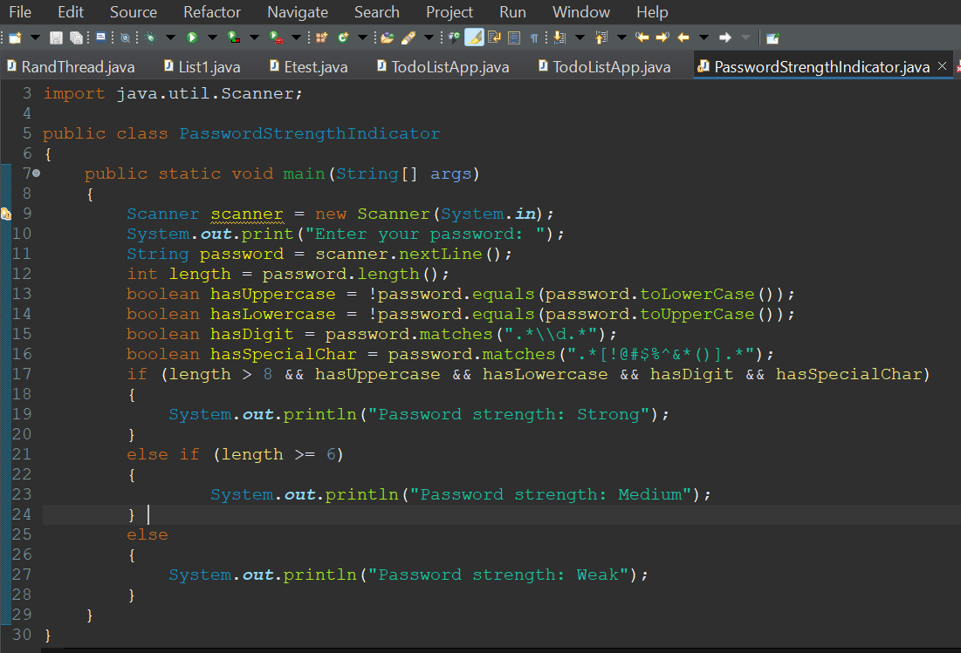

Now the factors I have considered for a password to be strong, medium or weak is shown below:

* **Strong Password**: For a password to be strong its string length should be above or equal to 8, it also should involve lowercase letters, Uppercase letters, digits, special characters.
* **Medium Password**: String length should be above or equal to 6.
* **Weak Password**: Its string length is below 6.

(Note: even if all the factors like Uppercase letters, digits, special characters all are involved if string length is not met it won’t be considered strong. Hence primary criteria as stated is string length.

Also if string length is above 8 but does not consider all other factors it will still be considered medium as strong password involves all password)

Now let’s see outputs for above code:

**OUTPUTS:**

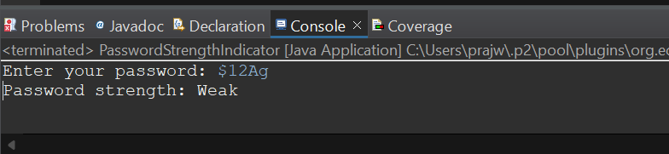

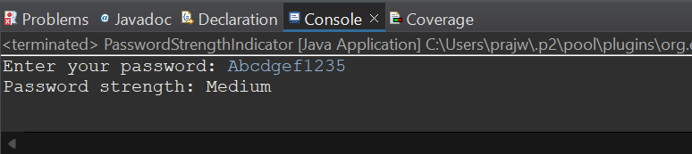

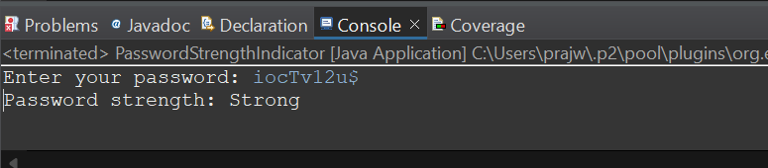

We can change and see various combinations of passwords and if condition is met we will know the strength level of password.